User Requirements from Prof Inggs

Figure 1 show the diagram of the overall system.

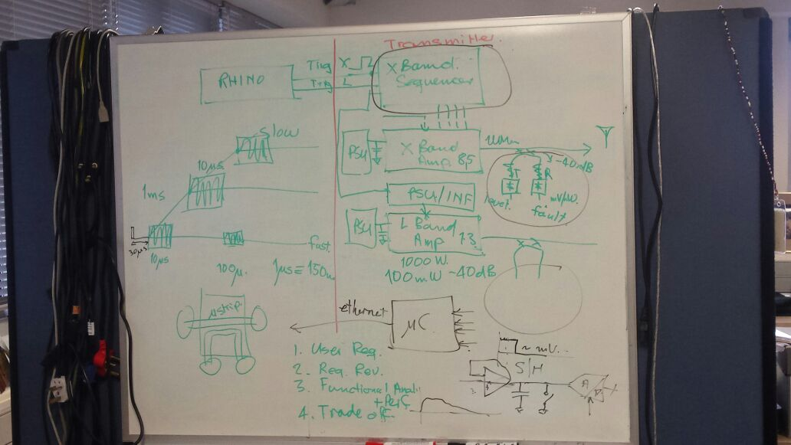

Figure 1: Diagram of the Overall NeXtRAD System.



Figure 2: Diagram of Transmit and Reverse Power Measurement Circuitry

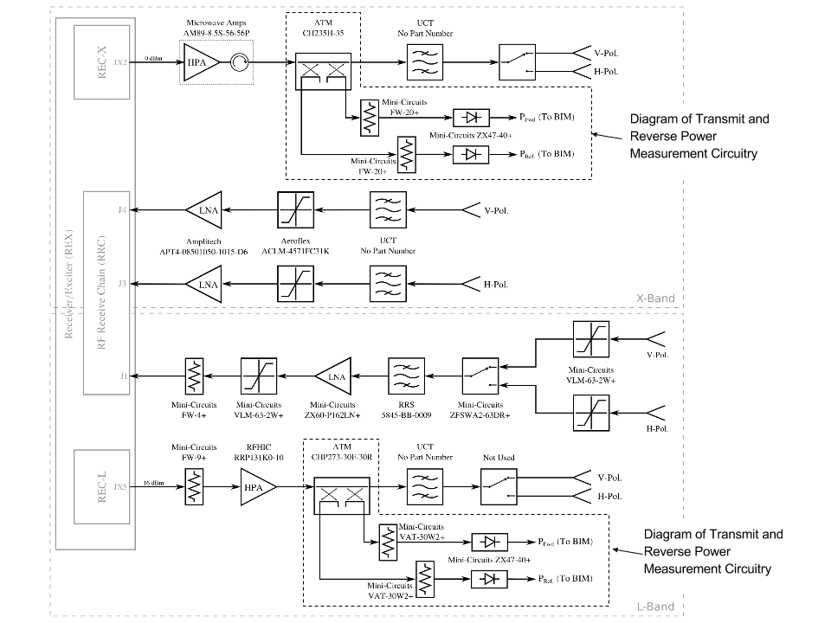

Figure 3: System Diagram of NeXtRAD RF Frontend With Part Numbers

The transmit and reverse power measurement circuitry in Figure 2 exists at the outputs of both the X and L Band amplifiers. This circuitry is coupled to the output of the amplifier that goes to their corresponding antennas. The voltage of the point *level* is directly proportional to the power of the incident signal and the voltage of the point *fault* is directly proportional to the power of the reflected signal. *Level* in Figure 2 is the same as PFwd. in Figure 3 and *fault* is the same PRef..

Pulse lengths vary from 1 us to 20 us. The Pulse goes out (one band at a time, X or L), exactly 30 us after the pre-trigger. A pulse is goes out every 1ms.

We were asked to design circuitry that measures the voltage levels from the points in the diagram labeled *level* and *fault* for both the X and L Band transmit and reverse power measurement circuitryand represents it digitally. Due to the fact that the pulse lengths are very short, sample and hold circuitry will be needed.

The forward and reverse power (peak values) must be sampled during the transmission, and these digital values from the measurements will need to be transfer via ethernet to the Node Controller.

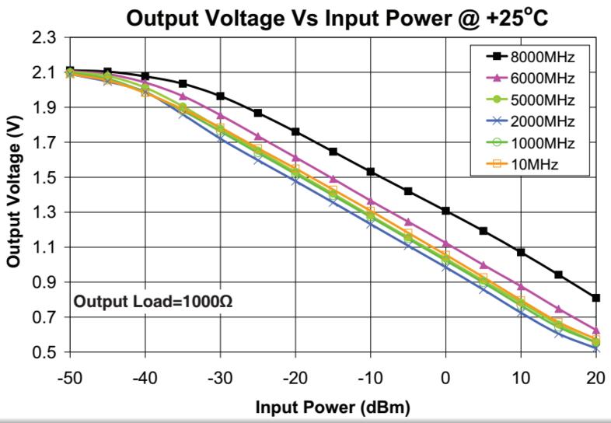

Figure 4: Output Voltage vs Input Power @+25OC for the Mini-Circuits ZX47-40+

|  |  |  |
| --- | --- | --- |
| Frequency Band | Component | Coupling(dB) |
| L Band | ATM CHP273-30F-30R | 30±1 |
| X Band | ATM CH235H-35 | 35±1.50 |

Table 1: The coupling in dB for the couplers

|  |  |  |
| --- | --- | --- |
| Frequency Band | Component | Attenuation(dB) |
| L Band | Mini-Circuits VAT-30W2+ | 30±0.3 |
| X Band | Mini-Circuits FW-20+ | 20 |

Table 2: The attenuation of the attenuators in dB

|  |  |
| --- | --- |
| Frequency Band | Net Attenuation due to coupling and attenuator (dB) |
| L | 60 |
| X | 55 |

Table 3: Net Attenuation due to coupling and attenuator